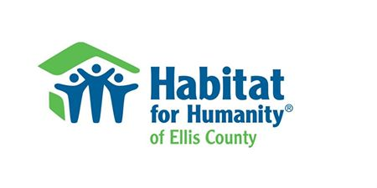
Initial Application
Which program are you applying for? Please check all that apply.
□ A Brush with Kindness Program –
Painting, Minor exterior building shell repair, Window repair/replacement, Weatherization/weather-stripping, Minor landscape grading to provide adequate drainage away from residence, Minor landscaping/trimming/removal, Porch repair, Handicap ramp construction/repair
□ A Critical Home Repair Program -
Ramp access to primary entrance, Hand rail to primary entrance, Grab bars in bathroom, Roof repair, Floor repair, Plumbing, Electrical, Other repairs that would affect the health and safety of the homeowners.

- Name and Contact Information of person making application:
Full Name:
Address of property where work will be done (must be primary residence of applicant):
Phone Number(s):
To evaluate your proposed project, we need the following:
- List the names, ages, and relationship to applicant of all other persons residing at this address:
- Proof that you are the owner of the property. If you hold the title in clear, a copy of your most recent property tax statement will constitute this proof. If you are still paying on the mortgage, a copy of the most recent yearly statement from the mortgage company will suffice, or you may send a copy of a recent payment coupon for the mortgage.

- Documentation of the combined income of all persons residing in the house. A copy of the most recent income tax filings for all persons residing in the house would be the most efficient way to do this.

- A brief written description of the work you want help with. It is not necessary to estimate the cost of the work.

Signature of Applicant: Date:
Return application and supporting documents to:
Jared Vaughn, Project Selection Committee, P.O. Box 444, Hays, Ks 67601

